**Hemant Maheshwari**

**CS305**

**Wire Frame Assignment**

**Target Audience**

The target audience for this application will be anyone who wants to manage their money, keep track of their income and expenditure. Also, people having trouble splitting their bills for group travels, group dinner, rents, groceries and more. Young adults having trouble managing finances would find this application useful.

**Personas**

**Alex**: He is an artist. He loves to travel. He goes out with friends almost every weekend for dinner or social events. He is having a difficult time splitting bills of travels, and dinners amongst his friends.

**Sarah**: She is a college student recently started working on campus as a tutor. She is having a hard time managing her expenses every month. She wants to get an estimate about her earnings, expenses and saving every month.

**Application Goal**

To help users streamline their finances and keep track of their income and expenses. Also, help people split or share bills amongst friends, family, and roommates.

As a user, I want to know how much I spent last month.

As a user, I want to split my bills among my friends with whom I had dinner last night so they can pay their shares to me.

**Application Features**

Splash Screen when app boots.

Every screen aligns itself accordingly when the device is rotated.

Camera activity for the profile picture and for taking pictures of the bills.

Data storage for pictures of the bill and all the transactions.

Sharing option available with friends.

**Wire Frame**

**Login Page**

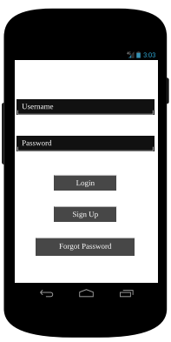

Summary Page

Sign Up Page



Send an email to user’s email with reset password instructions.

**Sign Up Page**

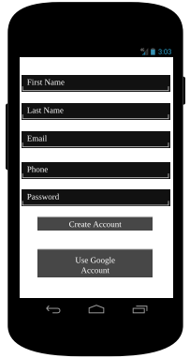

Creates a new user account and send user back to login page after account gets created.



Connect with google accounts to get all the information above.

**Summary Page**

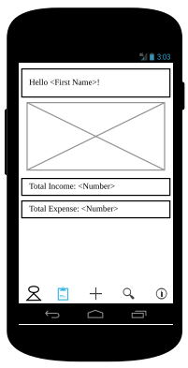

Shows a graph with user money flow (expense and income)

Shows basic information about monthly income and expenses

Activity Page



Account Page

Add Transaction Page

Friends Page Summary Page

The action bar in the bottom of the screen with icon for friends, summary, add transaction, activity and account is present on all the pages with same functionality.

**Friends Page**

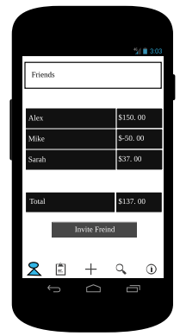

Overview of all friends and the amount of money either this user owe them, or they owe this user.

Option to invite friends. When clicked a popup will show up to enter email.  


**Transaction Page**

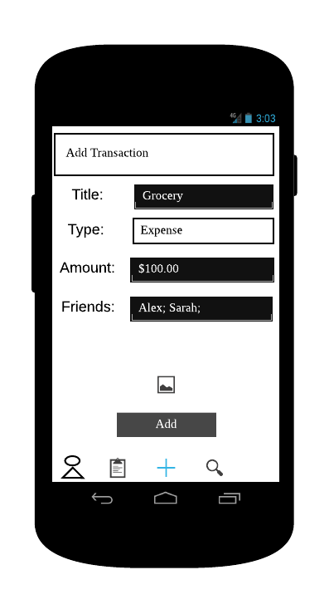

Option to select type of transaction- income, or expense.

Enable user to enter friends from list of all the friends.

Options to split money among friends

Option to attach picture of the bill (camera activity)

Saves the transaction. After transaction is saved if the transaction was of type expense it will bring the application to friends page else to summary page.

The field for adding friends to a transaction and splitting option only shows up when user selects ‘Expense’ from type of transaction.

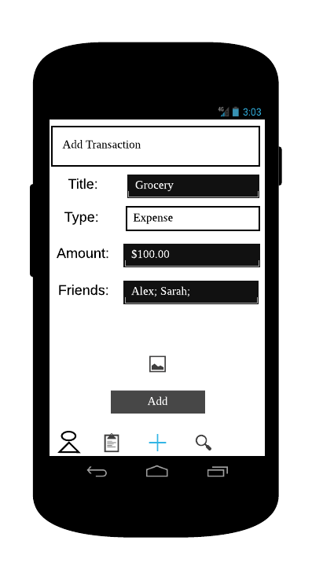

**Activity Page**

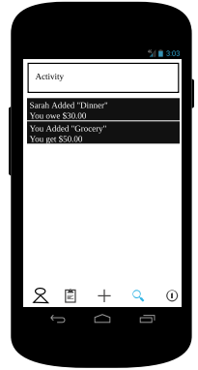

Simple overview of past activity either posted by this user or someone included this user in any expense.  


**Account Page**

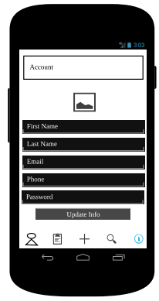

Option to choose picture for the account

Option to update personal and account information